**Introduction to React Components:**

* **Definition**: Components are the building blocks of any React application. Everything in a React app is either a component or inside one.
* **Function**: React components render views that together create the user interface (UI).

**Key Features of Components:**

* **Self-contained:** Each component has its own data, logic, and appearance.
* **Modularity:** Complex UIs are built by combining multiple components, like assembling Lego pieces.

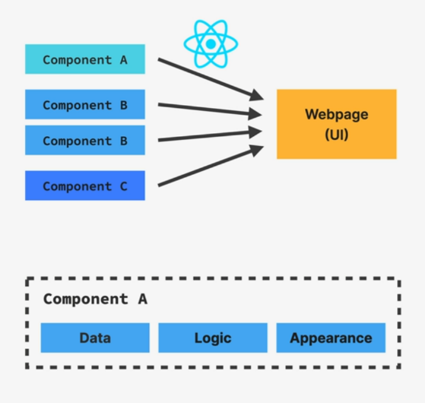

**Component Nesting and Reusability:**

* Nesting: Components can be placed inside other components, creating a hierarchical structure.
* Reusability: Similar UI elements can be created once and reused with different data using "props."

**Component Hierarchy:**

* **Component Tree:** This visualizes the parent-child relationships between components, helping understand how they interact and relate.
* **Parent and Child Components:** These terms describe how components nest and organize, crucial for managing component relationships.

